Enpresence, Inc.

BUSINESS PLAN

April 10, 2005

Headquarters:
601 E. 20th St. Suite 4F
New York, NY. 10010
+1 (917) 208-6124

Confidentiality Statement
The contents embodied in this business plan are strictly confidential and are supplied with the understanding that they will be held confidentially and not disclosed to third parties without the prior written consent of Enpresence, Inc.

Table of Contents
Executive Summary 1
Overview 1
Business Objectives 1
Offering 1
Strategy 2
Financial Summary 2
Management Team 2
Company Status 3
Service Offering 4
Overview 4
Products 4
Relationship Networking 6
Usage Scenarios 8
Product Roadmap 9
Technical Requirements 9
Technology Overview 9
Roadmap 11
The Market 13
The Mobile Data Market 13
Dating Market 14
SMS/Text Messaging Market 14
Social & Professional Networking Market 14
Target Enpresence Consumers 15
The Competitive Landscape 16
Competition 16
Competitor Overviews 17
Key Competitors 18
AciveMatch 19
BEDD 19
CrowdSurfer 19
Dodgball 20
MobiLuck 20
Serendipity 20
Product Comparison Matrices 21
Geographic Markets 21
Core Product Features 21
Presence Sharing Models 21
Primary Application of Technology 22
Revenue Models 22
Competitive Analysis 22
Financial Projections 23
Projected P&L 23
Key assumptions 27
Sales & Marketing 28
Partner Strategy 28
Direct Strategy 28
Pricing Strategies 28
The Team 29
Ben Taylor 29
David Cowing 30
Risks 31
Glossary 32
Appendix 33
Research 33

Executive Summary

Overview
Enpresence offers a suite of applications for mobile phones and mobile commerce that advances social networking by combining messaging with presence-awareness and location-based services and delivering a revolutionary opportunity to connect individuals and expand relationship networks. Enpresence was founded in 2004 to bridge the gap between online communities and the real world with an array of proximity- and location-based technologies for mobile devices. By enhancing the latest in wireless technology with proximity- and location-based services, Enpresence has revolutionized the way we can perceive and interact with the real world. Personal and professional networks expand when new relationships are formed through the physical proximity of interested individuals. Enpresence is building a network of relationships through mobile relationship networking, mobile commerce, and mobile messaging. Enpresence connects appropriate individuals as well as relevant sites and services, thereby creating important connections that expand both social and business networks.

Enpresence sells proprietary location- and proximity-based service to online dating and social networking services. These services use our product as a competitive differentiator as they seek to attract new subscribers and improve their ability to match eligible candidates.

Business Objectives
As a pioneer in the emerging mobile enabled relationship networking arena, Enpresence has been built to achieve the following major objectives:
- Build the world’s largest proprietary network of proximity-based that which network our users with other users and services.
- To extend current online dating services and other social networks to the real world through the application of mobile technologies.
- Advance location-based services (person to fixed location) to proximity-based services (mobile person to mobile person and/or fixed location) to provide highly contextual information.
- Establish a defensible proprietary network based on our suite of technologies.
- Demonstrate that the network effect for proximity services is sustainable while pioneering what will become a major market.
- Build a wildly successful business that bridges online services with the real world through contextually relevant information delivery.

Offering
Today’s most successful online businesses are those that make it possible for people to search for information, people, products and services. Companies like Google are information oriented while eBay makes it possible for people to locate many hard to find products and transact on them. Services such as Match.com and eHarmony facilitate the finding of people for various forms of social interaction. What these sites have in common is that they make it easier for people to find the most relevant information as quickly and accurately as possible. Users of these sites use them to take action – to find something, not because they are merely browsing. Another common between these companies is their inability to bridge the gap between the online world and the real world we spend our lives in. Enpresence has harnessed the power of the Internet and coupled it with proximity- and location-based services to give users a new level of context driven real world access to information. Our technology makes it possible for users to:
- Automatically find people whose characteristics match a search profile and who are close by.
- Be alerted to product offerings in a context that makes them highly relevant to consumers.
- Gain access location specific information.
- Share their location and presence within their personal network of relationships
- Communicate and message with their personal network of contacts through a single mobile messaging platform.

Our technology is installed on mobile phones and personal digital assistants for access to proximity- and location-based services. Our service is comprised of an online service that allows users to manage their search profiles and personal information, add members to their personal relationship network, browse and search the network of members, and perform community oriented tasks such as messaging.

Strategy
Our go to market strategy is to build partnerships with online dating services and social networks to extend their online person to person matching to the real world through the application of our technology. Our primary sales strategy is to target wholesale sales of our Mobile Relationship Networking service to online dating services, online communities, and online social networks. Developing a large install base rapidly is believed to be essential to building a defensible business. In conjunction with building a user base through partnerships we will build and promote our own relationship network directly.

Once we have achieved a sufficient install base through relationship networking we will expand on our mobile proximity- and location-based services by adding mobile advertising and commerce solutions.

Financial Summary
Enpresence is a startup with no current revenue. Revenue projections are based on the following projections:

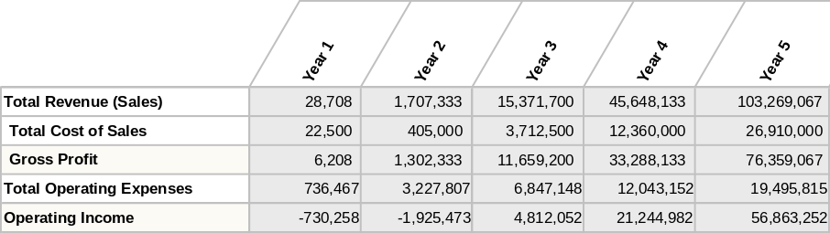
Figure 1: Summary financial projections

Management Team
Ben Taylor, Founder and President, has 11 years of experience in the high-tech industry as a consultant and entrepreneur. Ben began his career at Cambridge Technology Partners in the early 90s where he founded their Internet Services division and helped to build the company to $600 million through the growth of the Internet Services division to $150 million in two years. During his tenure at Cambridge Ben had the opportunity to work with David Cowing on numerous projects and has maintained a strong friendship. He left Cambridge to co-found NerveWire as a Vice President in 1999 where he played a number of important roles which included Chief Internet Architect, VP or Innovations, and CIO. His responsibilities included creating their services offerings, methodology, and best practices and included opening both the San Francisco and New York offices. Enpresence was sold to Wipro in early 2003. Early in 2002 Ben co-founded E5 Systems as VP of Operations where again he played a diverse number of roles and was responsible for building the services model for an offshore consultancy, creation of services and methodologies, and CMM certification. Ben has a BA in Art and Semiotics from Brown University. Further details can be found in the section titled The Team

David Cowing, Founder and Vice President, has 15 years of experience in technology, consulting, and management. He has worked on the management teams of startup companies, as well as led the development of teams and groups within dynamic consulting companies. David began his career at AdValue Media Technologies, where he was one of five founders and was responsible for a team developing a cross platform interface to a networked solution for buying and selling television spot advertising. After AdValue Media he worked at Cambridge Technology Partners, where he was one of the founders of their Internet Services practice and the east coast regional technical manager for a group of 120 people that generated over $18 million in revenue in its first year. Dave next played the role of Director of Technology for ZEFER New York, where he was responsible for developing the technology direction and organization, as well as providing thought leadership on technology projects. Most recently, David has been involved in assisting a leading investment bank in the development of a user oriented FX trading platform. Prior to that, David was the Chief Technologist for Niteo Partners, a systems integration division of NEC, where he consulted with projects and clients on technology issues, investigated potential uses of new/emerging technology, and worked closely with Niteo’s technology partners to address client technology challenges. Dave has a BA in Computer Science from Cornell University and an MBA from New York University.

Company Status
The company status of Enpresence is as follows:
- Incorporation: Enpresence, Inc is a New York based company that was founded in June of 2004 and incorporated in March of 2005.
- Employees: Currently full-time employees (2) consist of Ben Taylor and David Cowing. The extended development team consists of part-time resources and partner businesses for user interface and graphic design.
- Customers: As a new company we currently have no customers but will be starting a beta program in June of 2005. Enpresence is currently in talks with a number of potential business partners and anticipates one or more beta program partners.
- Revenue: Enpresence currently has no revenue but has expressed interest from a number of partners.
- Offerings: Our offerings are in beta and we are actively seeking business partners to participate in out beta program.
- Capitalization: Enpresence has been built through 9 months of hard work by Ben Taylor and David Cowing who have been working on this as a full-time endeavor.

Service Offering

Overview
Enpresence sells a Mobile Relationship Networking solution for Dating Services, Social Networking Services, and Mobile Phone Carriers that extends online communities to the real world through a unique set of proximity services. Our Relationship Networking service is an open technology platform, sharing real world presence and proximity between individuals and businesses. It combines intelligent matching technologies with social introduction. Enpresence Relationship Networking enables and empowers:
- Networking individuals seeking friendship or romance, business collegiality and other forms of social interaction,
- Mobile matching of individuals through secure profile matching of interests with user characteristics,
- Bridging online networks between people, services, and products in a user’s immediate vicinity.

Products
The Enpresence product suite consists of three mobile clients that extend our Relationship Network both to mobile devices as well as to networked computers. Our initial consumer products include three client applications for mobile phones. Our product line includes:
- Messenger: Messenger is an entry level product that is supported by the broadest number of mobile phones and which operates on a proven business model. It consists of a simple user interface that enables users to select their location from a list of published locations in the general area of the cell to which they are connected. Once they identify their location, it is then transmitted to people with whom they maintain relationships are within a certain distance of them. They can also exchange messages with one another without sharing phone numbers, for added privacy and security.
- Scout: Scout is our cornerstone product aimed at the mass market of relationship inspired individuals. It builds on Messenger by combining advance proximity and location detection with presence sharing and intelligent matching. Furthermore, users can exchange SMS messages and Instant Messages through a single easy-to-use interface.
- Networker: Networker is a premium product, incorporating our most advanced features and access to sophisticated relationship networking features, including: extended social networking through a mobile phone with the ability to exchange presence with friends of friends, join social groups, participate in discussion groups and maintain blogs through the Enpresence Relationship Network.

The following matrix details the major features of each product.

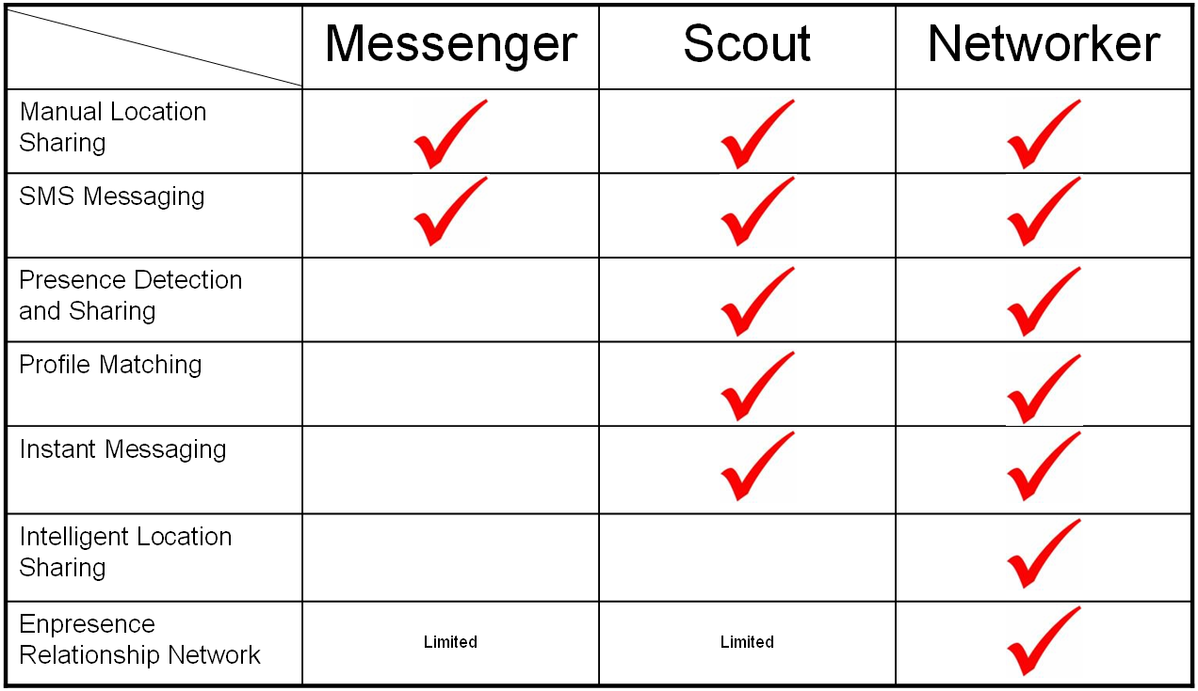

The core features of our products include:
- Location Sharing: Messengers advanced user interface enables users to easily select their current location from a list of registered locations in their immediate proximity and share their presence with others. Their presence is sent to the Enpresence Relationship Network and relayed to a user’s personal network of friends.
- SMS Messaging: SMS provides message routing and broadcasting to members of personal networks. When utilizing Proximity and Location information, users can enhance their messaging experience with presence-related information while messaging. SMS text messaging is currently a $4.4 billion industry.
- Presence Detection and Sharing: Automatic detection of the presence of other users and sharing of presence when a relationship exists between them. Users who are detected or who are logged in to our online service automatically appear on a “buddy” list on the mobile device.
- Profile Matching: Users can have one or more search profiles which contain a set of criteria they use for finding people whom they would like to add to their personal network(s). Each profile contains a different set of match criteria and thresholds that constantly scan the user’s proximity for new potential matches.
- Instant Messaging: Enpresence Instant Messaging enables members of any Relationship Network to exchange messages instantly from mobile to mobile, mobile to PDA, and mobile/PDA to Internet users of both Enpresence’s messenger and major providers of Instant Messaging services.
- Intelligent Location Sharing: Anywhere a user comes in proximity to an Enpresence Hotspot or to other user whose location is known, their location is shared with the Enpresence Relationship Network. Through location sharing, the Enpresence Relationship Network is able to bring to bear a variety of location based services that are contextually relevant to the user.
- Enpresence Relationship Network (ERN): Access to the ERN enables users to mine their personal networks and the extended networks of the people with whom they share relationships. Working the network enables users to build and leverage ever expanding social networks.
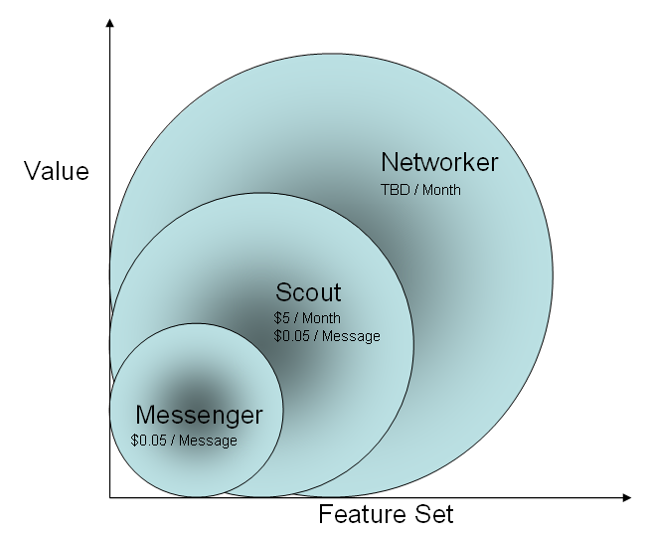

Relationship Networking
Enpresence has harnessed state-of-the-art technology and business innovation to bring to market a service that expands users’ awareness of other people, products, and services in their immediate vicinity in a contextually meaningful way. Picture two individuals walking down a street unaware that they are passing a potentially interesting relationship or an existing friend – the Enpresence Relationship Network will facilitate networking these individuals through:
- Presence Detection: Detection occurs anywhere within a range that can expand to 100 yards, or to whole city blocks or entire cities.
- Relationship Sharing: The network checks for existing relationships and automatically shares presence between networked individuals allowing them to know that a friend or colleague is close by.
- Social Introduction: In the event that users are not already networked, the Enpresence Relationship Network will securely, and without the transfer of any personal information, check for a relationship match of various types. Relationship matches can be romance, friendship, or business-oriented, modeling real world relationships, utilizing the criteria people use for creating or differentiating types of relationships.
- Network Expansion: When a match occurs between two users they are given the opportunity to opt into a personal network by creating a relationship that enables them to communicate, to maintain presence awareness, and to leverage one another’s extended network of users.

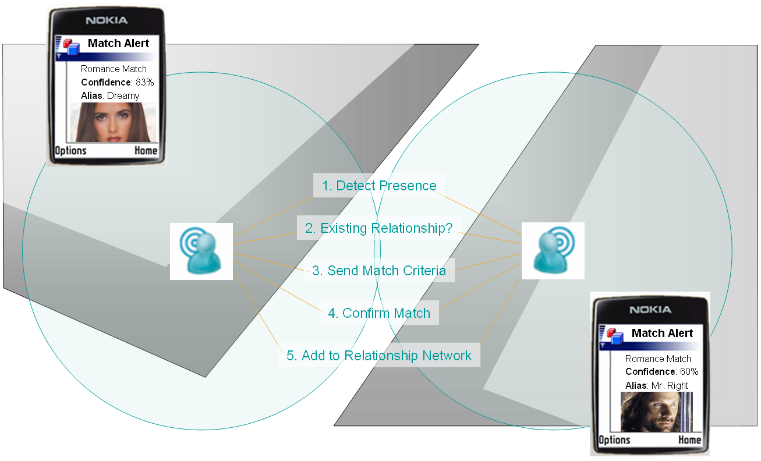
Figure 2 - Relationship Networking

The Enpresence Relationship Network operates on mobile phones and personal digital assistants (PDAs) and currently shares two levels of presence, depending on the capabilities of the hardware. Local presence is typically within 10 to 100 yards, while the extended presence includes individuals anywhere in the world, connecting over the Internet.

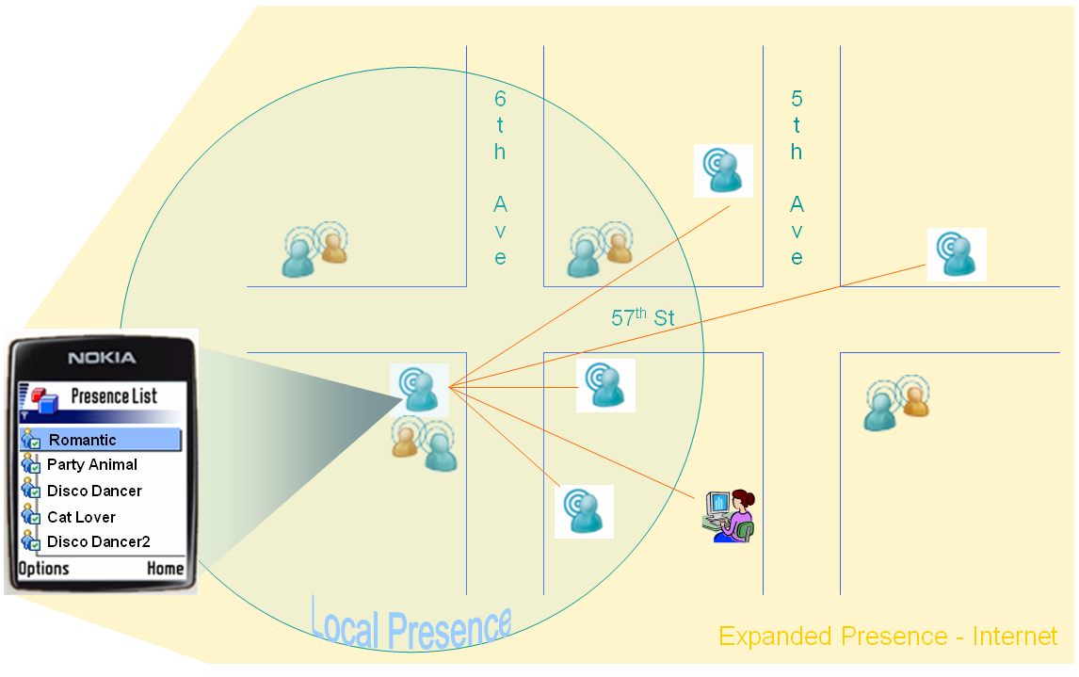
Figure 3 - Presence Sharing

Usage Scenarios
The Enpresence Relationship Network supports many interaction models and the following usage scenarios are meant to demonstrate some of its potential:
- Dating and Social Introduction: picture a subscriber of discerning taste who has recently moved to a new city and wants to meet cool people—maybe even Mr. Right. Going to bars, the gym, all the places people are supposed to meet doesn’t work. But one day, at the park, she pulls out her phone and finds that someone with a profile that really meets her interests just happens to be in the park too.
  - After several deep breaths and a quick prayer, she accepts an introduction and gets up the moxie to shoot the man who has all the characteristics of Mr. Right a digital handshake and ask if he’d like to meet face to face.
  - The man is definitely interested but subtly hints that he’d like a little more information, and perhaps a picture.
  - The subscriber of discerning taste responds with a fuller profile and a snapshot.
  - The lucky guy not only likes what he sees but is ecstatic to finally find someone who also loves to read historical novels and play paintball in the buff.
Note: Dating and social introduction leverage user profiles; however matching criteria may be leveraged to enable or introduce many forms of relationships beyond social dating.
- Presence Sharing and Messaging: users who share a relationship can send messages between mobile devices (phones and PDAs) and between mobile devices and networked computers in a fashion similar to Instant Messaging. Enpresence messaging differs from Instant Messaging in that the presence that is shared not only includes whether or not someone is available, but it also shares their proximity, with the potential to share their specific location. Presence sharing and messaging are the core of maintaining a strong relationship network through seamless online and mobile messaging.

Product Roadmap
The evolution of our product suite includes a number of important additions. The following items are on our product roadmap and the specific order will be dictated and enhanced by market research and user feedback:
- Location based services
- Private Labeled service for social networks
- Integration with major Instant Messenger providers
- Mobile advertising and product promotion
- Mobile commerce
- Community Services
- Mapping
- Subscriber Management

Technical Requirements
The Enpresence Relationship Network is comprised of two major components. The first is a client application which runs on mobile phones and is written in Java (J2ME). The second component is the Relationship Server which manages all relationships and is the heart of the Enpresence Relationship Network.
Technical requirements for the mobile client are as follows:
- Symbian Series 60 Operating System
- 500 KB of available storage on the device
- Bluetooth support using JSR-82 (Java Bluetooth Implementation)

The Enpresence Relationship Network will runs on any device that supports Java and the JSR-82 API, but it has not yet been tested on the full range of devices available in the marketplace today. Note: we currently only test on the Nokia Series 60 platform from Symbian.

Technology Overview
The Enpresence Relationship Network is an open server platform that has been built to easily and seamlessly integrate with 3rd party social networks to leverage existing user profiles. By leveraging member profiles of our business partners we can extend partner networks into the real world, while providing advanced matching and presence sharing. Search criteria can be maintained using partner websites or directly through Enpresence’s Online Relationship Network which provides a broad range of networking tools. Our underlying systems are built to support the following ecosystem model.
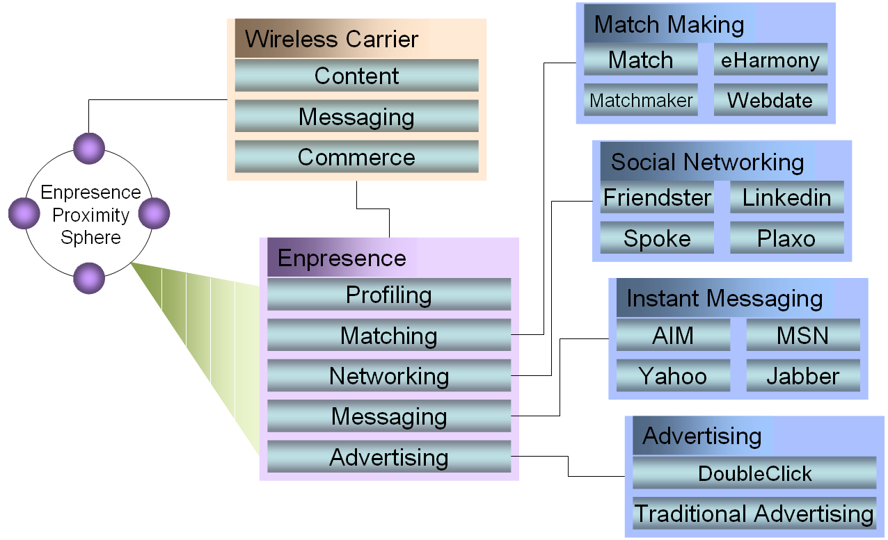

Proximity based relationship networking between individuals utilizes Bluetooth technology for local area presence detection and networking. User presence and proximity is maintained in four levels of proximity:
- Internet Presence: The scope of proximity covers all users who are connected to the Enpresence Relationship Network via the Internet (using computer, mobile phone or PDA) and, like Instant Messaging applications, simply shares the presence of others connected to the network.
- User-Specified Presence: Here proximity takes into account geographical location by enabling users to broadcast their location in order to have it transmitted to their relationship network. Designed to take advantage of low-end mobile platforms, this function supports presence broadcasting using SMS as it is used by many mobile social networking solutions.
- Location-Based Presence: Through Enpresence’s service, GPS enabled phones will provide relative proximity for any previously-determined distance. . GPS phones broadcast their location to our Relationship Network which in turn shares proximity and presence with members of a Relationship Network who are in close proximity. Currently only a small number of phones in North America support this feature so it has not yet been integrated into the Enpresence technology infrastructure.
- Short-Range Wireless Presence: Using Bluetooth, presence is detected and shared over a local network between devices providing a very granular form of proximity sharing among members of a relationship network.

The Enpresence Relationship Network shares proximity and presence information between users who are joined through direct opt-in relationships. Users who do not maintain a relationship can join relationship networks by searching for one another using the Enpresence website, or through automatic detection by the Enpresence Relationship Network mobile software. The following diagram demonstrates a broad Enpresence network, from wireless device to wireless carrier and on to the Enpresence Gateway, which interconnects users with Enpresence partners and the core Relationship Server.

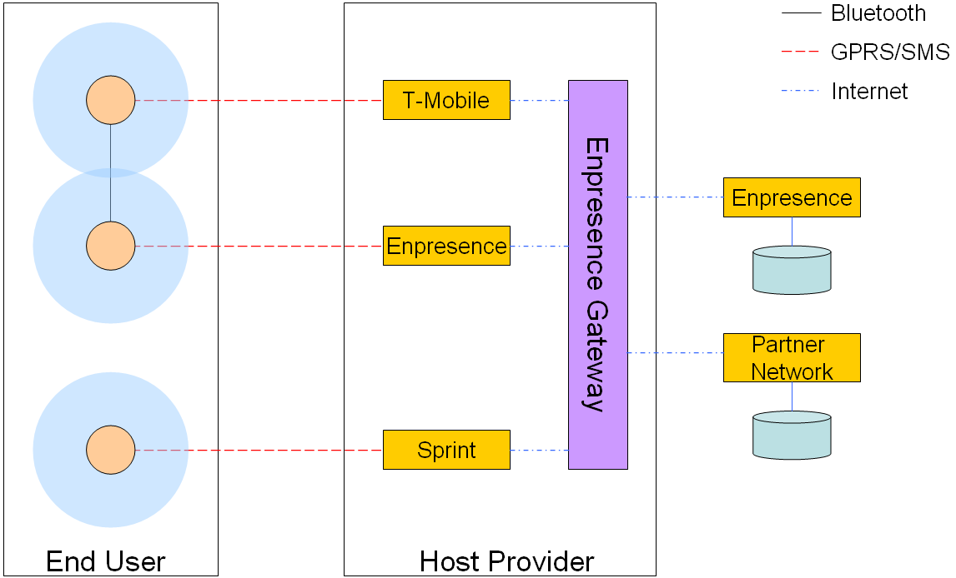

Roadmap
Our product roadmap includes many enhancements to our current suite of products. As we gain more market intelligence we will refine our roadmap and prioritize the implementation plan accordingly. Our current roadmap includes the following enhancements:
- Location-Based Service Enhancement: As mobile phones increasingly include access to GPS and other forms of location detection, we will enhance our products to leverage these expanded ways of detecting and sharing location enhanced presence. Location will be detected using both GPS and cell tower triangulation, for location identification.
- Co-Branded Products: If our customer market (carriers and/or social network providers) demonstrates demand, we will work to co-brand both our mobile applications and website to support these types of partnerships.
- Instant Messenger Integration: As our user base grows, we will expand our messaging capabilities to include message exchange with major Instant Messenger providers such as Yahoo!, AOL and MSN, thereby enabling users to incorporate Enpresence products in their everyday messaging usage.
- Mobile Advertising: By combining our advanced profiling, user matching and presence sharing, we can uniquely deliver promotional materials to mobile users who are contextually relevant. We expect this to generate a significant amount of revenue once our Relationship Network is of a sufficient size.
- Mobile Commerce: Extending the possibilities of our Mobile Advertising platform, we anticipate providing transactional capabilities that enable the purchase of goods and services. Users who are offered promotions on books while standing in a bookstore will simply be able to accept an offer and pick it up at the checkout counter on exiting the store.
- Community Services: We anticipate expanding our online services to include communities, chat groups, and blogging.
- Mapping and Directions: With the anticipated growth in consumer demand for location-based services, we will incorporate appropriate mapping and direction enhancements into our core products.
- Mobile Games: We are currently developing mobile games that combine proximity and location detection to provide an entirely new type of game. There will be no question who got tagged in the future …

The Market

The market for the Enpresence mobile relationship networking service is the result of the convergence of several markets: mobile data services (including text messaging), internet dating services, and social networking services. By bringing capabilities together from each of these industries, Enpresence is well-positioned to capitalize on the emerging mobile relationship networking market.

There are 23 million consumers in the Enpresence target market in the US alone, and that this will swell to 38 million by 2010. This market is represents the extension of the online dating, SMS text messaging, and social networking markets. Mobile relationship networking is an emerging part of the $17 billion global market for mobile data services that analysts forecast will grow to $78 billion by 2007. There are 23 million consumers in our target market in the US alone, and that this will swell to 38 million by 2010.
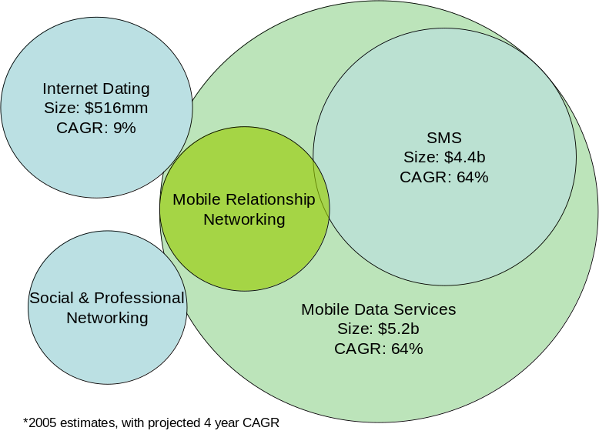
Figure 4: Mobile Relationship Networking Market

The Mobile Data Market
While the mobile data market in the US lags behind that seen in Japan and Europe, it is a substantial market and its growth is beginning to accelerate. Currently an estimated 31% of mobile users use data services, with the number of users expected to grow with a CAGR of 11% over the next 3 years (vs. 4% growth in mobile voice services). This is expected to spur a growth in the US market for data services from $2.7B in 2004 to $11.8B in 2007. While the current leading segment of this is text messaging, signs are appearing that next generation applications, including information services, instant messaging, games will account for growing percentages of the data services market.
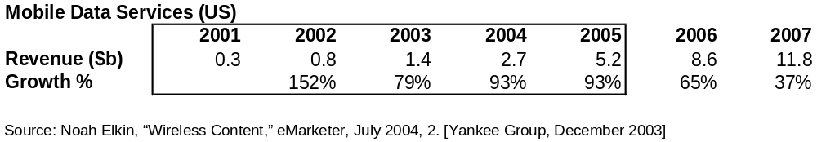 Figure 5: Mobile data services market growth (US)

Dating Market
The online dating market is expected to generate $516 million in 2005. The leaders in the space include Match.com, Inc., Yahoo! Personals, and eHarmony. This space has grown rapidly over the past 4 years, although it is now showing signs of slowing.
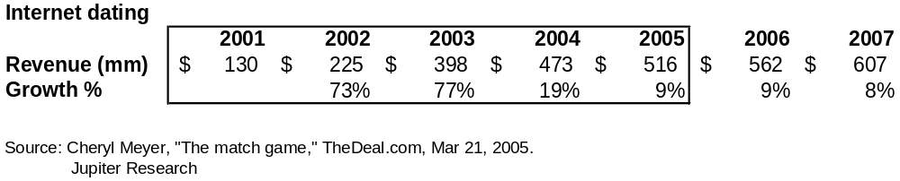
Figure 6: Internet dating market growth

SMS/Text Messaging Market
The SMS/Text messaging market is expected to reach $7.3B by 2006. This represents the largest portion of the mobile data market, as consumers have adopted text messaging as the leading person to person collaboration application on the phone. Quickly following the success of SMS, is MMS, which enables users to send rich messages including pictures, video, and longer text messages. Text messaging is one of the techniques being used for early location-based messaging and mobile dating services.

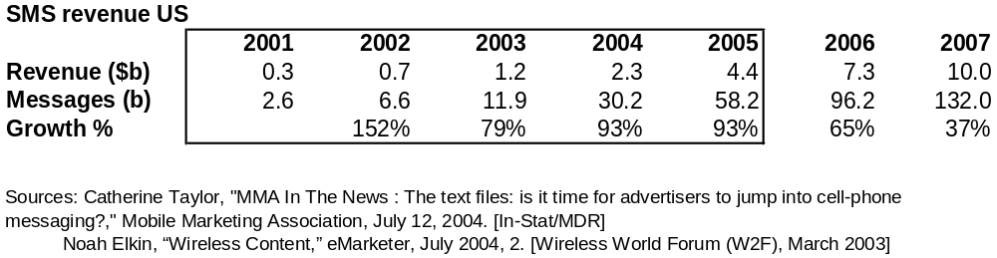
Figure 7: SMS market growth (US)

Social & Professional Networking Market
The social networking market includes networking sites supporting personal networks, such as Friendster, Tribe, and Meetup. The professional networking market is an emerging space, with companies such as LinkedIn and ZeroDegrees providing users with access to a growing network of individuals to tap for business purposes, such as identifying leads, recruiting, and seeking business partners. Given that players utilize a variety of business models, including selling content, providing subscriptions, and selling job listings, the revenues of the market are difficult to calculate and compare However, companies like Tickle and Friendster have attracted users and investors.

Site | Location | Launch | Invested
Friendster | Sunnyvale, Calif. | March 2003 | $13M
Tickle | San Francisco | 1999 | $8M
Tribe | San Francisco | Jan. 2003 | $6.4M
LinkedIn | Mountain View, Calif. | May 2003 | $4.7M
Meetup | New York | 2002 | $1M
Figure 8: Social networking investments

Target Enpresence Consumers
The initial market for the Enpresence service is the mobile relationship networking market, consisting of users interested in connecting for romance, as well as those who wish to remain connected with friends. The two target groups are 18 to 35 years old and single adults. These groups, combined, represent a target market of 130 million individuals in the US. Narrowing this to wireless subscribers with data-ready phones, we estimate the total to be about 23 million individuals in the US currently, and that it will grow to 38 million by 2010 (see Figure 9).

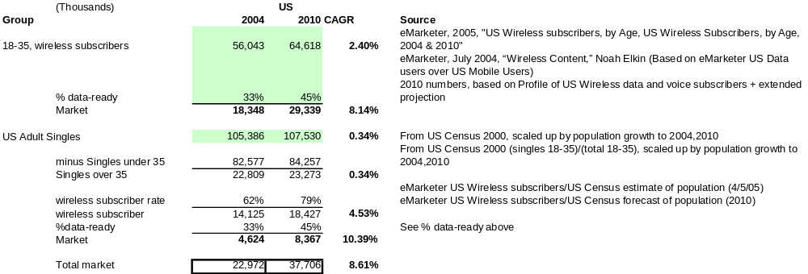
Figure 9: Target consumers - US

The Competitive Landscape
The Mobile Relationship Networking marketplace is an emerging market comprised of a limited number of relatively small new/start-up companies. In addition, there are several large players in the online dating arena who have mobile extensions to their services which offer low-end solutions which indirectly compete with these recent developments in mobile relationship networks. Enpresence is positioned to dominate the Mobile Relationship Networking marketplace easily because of vastly superior products providing greater user value and built on a technology platform that can be easily integrated with existing 3rd party players (partners) to gain rapid network growth and consumer adoption.

The Mobile Relationship Networking marketplace is expected to grow rapidly as data-related service and products establish themselves in the mobile arena. Furthermore, the convergence of online services with real world products and services through a variety of location-based services will increase user adoption, as increasingly valuable applications are introduced to the market. Current players in the Relationship Networking arena are well established and the market is warming to the extension of online networks to real world applications that will drive increased revenue for Mobile Relationship Networks and mobile phone carriers. Online Relationship Networks that operate over the Internet fall in several categories and companies such as:
- Dating Services
  - Match.com
  - Yahoo! Personals
  - eHarmony
  - Lavalife
- Social Networks
  - Friendster
  - Tickle
  - Tribe
  - Meetup
- Professional Networks
  - ZeroDegrees
  - LinkedIn

These online relationship networks are all potential partners of Enpresence and are considered to be our primary consumer base, as they look to extend their existing networks into the real world using advanced presence sharing and proximity detection.

Both the Dating and Social Network segments of the Online Relationship Networks marketplace have a number of mobile competitors that offer either mobile-only or hybrid online/mobile solutions. The mobile-only segment is well established and has a proven business model built on the exchange of SMS messages with members of a relationship network. The hybrid segment, on the other hand, is very limited and contains a very simplistic solution from Match.com that is not integrated with its online offering or with a SMS/WAP message-based service from Lavalife.

Competition
The Mobile Relationship Networking marketplace is an emerging marketplace with only a few slightly overlapping products. Most players are new, with small customer bases and little or no revenue. Mobile relationship networking products typically include a mix of the following core features:
- SMS Text Message Relaying: Message relaying to members of a relationship network using SMS is the most common form of mobile relationship networking today. Instead of sending messages to one another directly, messages are routed through the service provider for a fee. Messages can be sent to individuals or to a range of community oriented applications which include social clubs, broadcast messages from topic related channels, and many other forms of interactive communication. Furthermore, there are a number of different types of messages, some of which include flirts, location updates, and text messages.
- Location-Based Services (LBS): Location services are a powerful way of delivering highly customized and contextually relevant services to users with the added benefit of proximity-, location-, and time-based personalization. These LBS provide the user with a lens through which to view products and services in the immediate vicinity.
- Presence Sharing: The ability to see if someone is “on-line”, often coupled with messaging capability is an incredibly useful component of any messaging system and is necessary for relationship networking. Presence sharing broadcasts the availability of a member of a Personal Relationship Network. In the online world of Instant Messaging, presence typically means an individual is available for messaging and can be reached immediately. In the case of solutions such as Dodgeball.com, presence includes availability and location, which is an important differentiator in this developing marketplace.
- Presence Detection: Presence detection is the automatic detection of other members of a Relationship Network in close proximity to the user. Think of it as identifying someone wearing a sports jersey for your favorite team, who must therefore be someone who shares a common interest. Automatic detection identifies individuals with whom a relationship already exists or could be developed.
- Profile Matching: Profile matching is the matching of user preferences with the characteristics of someone they may or not be interested in getting to know. If there is a substantial match (one that meets both parties’ thresholds), they are introduced and prompted to begin a dialog and to exchange information – perhaps to start a relationship of one form or another.
- Online Community: Online communities bring together many community-oriented services such as browsing, blogging, messaging, and many other forms of social interaction.

Our competitive landscape includes a number of players who are reviewed in further detail below. Following is a comparative matrix of the core features of our competitors.

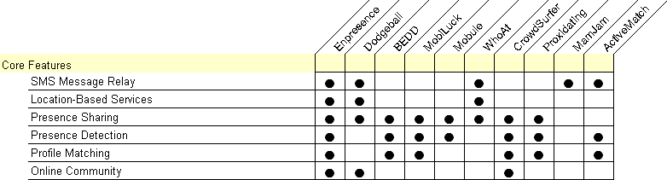

Though these competitors demonstrate competing technologies their demonstrated go-to-market strategies are all direct to consumer or carrier oriented. Enpresence believes the player with the largest sustainable network of installations and services will clearly win in the new market. As a result, our strategy of selling to established relationship networks will maximize our ability to build a defensible network.

Competitor Overviews
Mobile Relationship Networking is rapidly advancing as technology progresses and program/service adoption increases. As a result, the competitive landscape is comprised of three broad categories associated with the enabling technologies. These enabling technology categories include:
- SMS Text Messaging Services: These services rely primarily on the sending and relaying of text messages using the SMS protocol, which is widely supported by mobile carriers and phones. This has become a fairly crowded market space since services such as MamJam’s are included as SMS text message communities. However, the number of message-based communities that also share presence is limited to the following only:
  - Dodgeball
  - WhoAt
  - MamJam
- Proximity Detection Services: These services rely on technologies such as Bluetooth to sense the presence of other users within the immediate proximity of a user (up to 100 yards). The complete list of these services includes:
  - CrowdSurfer
  - BEDD
  - MobiLuck
  - Mobule
  - Proxidating
- Location-Based Services: Location-based services leverage the Global Positioning System (GPS) satellites or cell triangulation in order to determine the approximate location of a mobile phone. Proximity is then determined by comparing the know location of two or more users, and is then coupled with a geographical map showing relative distance and directions on how these users may meet. Most location-based services relay fixed (known) locations to mobile users. Mobile Relationship Networks take this a step further by relaying the dynamic location of two or more individuals. The only known competitor in this category is:
  - ActiveMatch

Though Enpresence offers products which compete in all three of the above mentioned categories, we believe our greatest area of opportunity and competition lies in the combination of Proximity Detection Services and Location-Based Services. We are uniquely positioning ourselves to be highly competitive in the rapid development of our Relationship Network through partnerships.

Our competitors are doing business in the following markets:

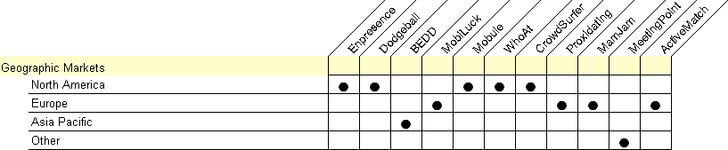

Key Competitors
Key competitors whose products and services are closely aligned in features and/or enabling technologies include the following:
- ActiveMatch from Simeda, headquartered in München Germany
- BEDD, headquartered in Singapore
- CrowdSurfer from Small Planet, headquartered in Los Angeles California
- Dodgeball, headquartered in New York, New York
- MobiLuck, headquartered in Paris, France
- Serendipity by Mobule, located in Cambridge, Massachusetts

Enpresence’s suite of products have a much greater scope of functionality and demonstrate a vision for Mobile Relationship Networking which is sure to expand this nascent marketplace rapidly. Detailed comparative charts can be found at the end of this section. Following is an overview of each competitor, its key features, and perceived threat to Enpresence.

AciveMatch
ActiveMatch is the only solution we have found that we believe uses Cell Triangulation and a centralized server for proximity detection. The location of each user is registered on a central server and when two users are within a predetermined distance (measured in number of cells away) a match is run and presence shared, in the event of a match. ActiveMatch is licensed directly to users for a onetime fee of €9.95.
Competitive Strengths:
- By using Cell Triangulation, ActiveMatch can detect and share presence over a large geographical area.
Competitive Weaknesses:
- Cell Triangulation as a form of user location detection is dependent on the mobile carrier’s controlled network for cell triangulation information, which may be of limited availability.
- Proximity detection requires each user’s mobile phone to post its location frequently to a central service, thereby driving mobile data consumptions and costs up for end users.
- Security and privacy are low since once a match is detected, ActiveMatch simply shares the contact information of the matched persons so they can SMS or call one and other with no privacy or opt-in support.

BEDD
BEDD is a phone-to-phone solution using Bluetooth for presence-detection and sharing. BEDD’s service provides users with a feature-rich solution for mobile communities that are within Bluetooth range (up to 100 yards) of one and other. BEDD performs presence detection, profile matching, picture sharing, messaging, and other functions. We consider BEDD to have one of the most competitive Mobile Relationship Networking solutions. Users are charge $0.98 per month, billed as a premium service on users’ phone bills.
Competitive Strengths:
- Rich feature set that includes presence detection, profile matching, picture sharing, messaging, and other functions.
- BEDD has been in business since 2001, though their product was not commercially released until May of 2004.
- There is no carrier dependence for the exchange of data between phones or with a centralized server.
Competitive Weaknesses:
- BEDD’s service does not include an online community or the sharing of presence beyond the range of Bluetooth.
- Presence is restricted to the range of Bluetooth and does not contain any location information.

CrowdSurfer
CrowdSurfer is a phone-to-phone solution that uses Bluetooth for presence detection and sharing. The CrowdSurfer mobile solution is further enhanced by a web community in which users can view each others’ profiles and photographs, and send messages. Though CrowdSurfer provides both a mobile client and an online community, the breadth of functionality of the mobile client is quite limited. Currently there is no charge for the use of this service.
Competitive Strengths:
- A web community that enables network building and messaging.
- Limited profiling – users are restricted to a single non-functionally oriented personal profile.
- CrowdSurfer has an established network of users that seems to be growing.
Competitive Weaknesses:
- Presence is not shared between online and mobile users.
- Profiling is limited and there is not matching of individuals.
- Presence is restricted to the range of Bluetooth and does not contain any location information that would enable a broader sense of shared presence.

Dodgball
Dodgeball is a phone-to-phone solution that uses SMS text messages to share presence and location between users. Users can also exchange messages, including flirt-type messages, with one another over the Dodgeball network. Users can send text messages to a centralized server with their location and have it relayed to their personal Relationship Network of individuals within a 10 block radius. Currently there is no charge for this service, which does limited advertising.
Competitive Strengths:
- No phone-based software is needed beyond the nearly ubiquitous SMS client included on most contemporary phones.
- No software installation is needed, resulting in no incompatibilities and a simple online registration process.
- The Dodgeball website provides basic social networking and the ability to cull through the Dodgeball network for interesting people share similar interests
Competitive Weaknesses:
- Location must be transmitted using text messages with a central server. If a location is not known by the system, location cannot be shared. In the event that users moves from one venue/location to another and do not update the server, their location is inaccurate.
- Messaging and location-sharing is cumbersome, requiring cryptic messaging.
- Profiling is limited to a single poorly-structured profile.
- No profile matching capabilities exist.

MobiLuck
MobiLuck provides a Bluetooth-enabled phone-to-phone solution for detecting other phones, and includes profiling and profile-based matching as well. Users can exchange messages, profiles, pictures, and other files using Bluetooth. There is no online community, and presence-sharing is limited to the shared presence of users within Bluetooth range. MobiLuck currently charge users €13 to license the product.
Competitive Strengths:
- Automatic presence detection
Competitive Weaknesses:
- MobiLuck does not have an online component that promotes and extended Relationship Network.
- Messaging is not fully integrated into the product resulting in messages being delivered to the phone inbox instead of an integrated inbox.

Serendipity
Mobule is a research project developed at MIT Media Lab as part of the doctorial research of Nathan Eagle, and geared towards research. Originally intended for instigating interaction between people in social and corporate situations, Serendipity can be used for far more than matchmaking, however. One of the more radical ideas could use the concepts behind Serendipity to help understand the impact of human social networks on disease propagation through computational epidemiology. Though Serendipity is not in the marketplace yet, we believe the vision behind the product pits it as a competitor in the Mobile Relationship Networking space. Currently it is not known if it will be formed into a business venture.

Product Comparison Matrices
Our understanding of the competitive landscape has been summarized into several key graphs which demonstrate how Enpresence fits into the current marketplace of Mobile Relationship Networking solutions. Our analysis includes the following models:
- Geographical markets
- Core product features
- Presence sharing models
- Primary application of technology
- Revenue models

Geographic Markets
Enpresence plans on focusing its growth in the United States until its business model is proven, while keeping an eye on the European market. Companies offering competing technology are currently fairly evenly distributed between the United States and Europe.

Core Product Features
Core product features are described in detail above in section titled Competition.

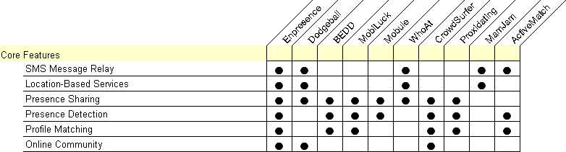

Presence Sharing Models
Enpresence distinguishes itself through its robust list of presence-sharing and detection capabilities. Shared presence actively extends Relationship Networks by notifying users of the presence of members of both Personal Relationship Networks (similar to an Instant Messenger Buddy List) and entire Relationship Networks (the entire membership base of a Relationship Network Provider). Active participation in any social network is driven by access to and awareness of a personal community of people seeking and maintaining relationships. Enpresence harnesses the power of proximity detection and couples it with presence sharing to bring new dimensions to presence sharing – proximity and location.

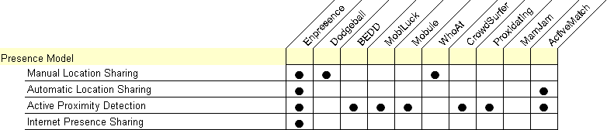

Primary Application of Technology
The primary value proposition of the solutions our competitors have in the marketplace stem from their application of several technology areas – presence sharing, proximity detection, profile matching, messaging, and community related services. The application of these core technologies has driven their positioning in the marketplace, as can be seen below.

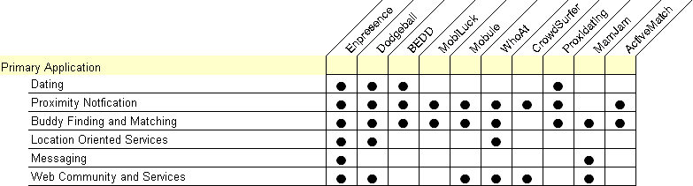

Revenue Models
In this developing market, it is of little surprise that revenue models vary widely and include a number of competitors who currently are not demonstrating any revenue model as they focus on driving adoption. Here is how Enpresence stacks up against its competition.

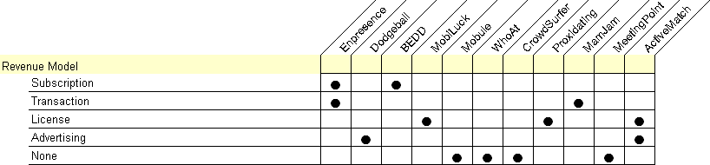

Competitive Analysis
All of the above mentioned competitors are new to this emerging market with inferior technology and limited funding. We believe that through our unique strategy, superior technology, and a substantial investment we can become a highly profitable and successful company.
Financial Projections

Projected P&L
Our current 5 year projection (see Figure 10) is based on growth expectations that are inline with those seen in online communities. In this expected case, the company reaches break even in the first quarter of year 3. In this quarter, the user base is expected to have reached the 1 million mark, largely through the acquisition of partners. To reach this break even point, a total investment of $3 million will be required.

The projection assumes slow customer acquisition in year 1, as the technology is completed, operations are set up, and the sales & marketing strategy is implemented. We expect customer acquisition to accelerate in year 2, as early proof of customer and partner adoption feeds into the business development process.

The goal of the model is to achieve a stream of revenue by utilizing a subscription structure. Partners will resell a co-branded version of the service with a subscription fee based on each bundle of one thousand users. It’s anticipated that they will be able to mark up the service by 2 to 3 times the fee paid to Enpresence. In the direct model, customers will be charged a monthly subscription fee of $5 to 10 according to the fee schedule in the projections. Note that the fee varies do to anticipated changes in customer demand as the value of the service becomes evident and growth in potential competitive offerings.

Detailed pro forma financial statements for the first year can be seen in Figure 11, Figure 12 and Figure 13. While the operation is kept fairly lean, funding is required to support the R&D and sales & marketing required to bring the service to market.


Figure 10: 5 year projected P&L

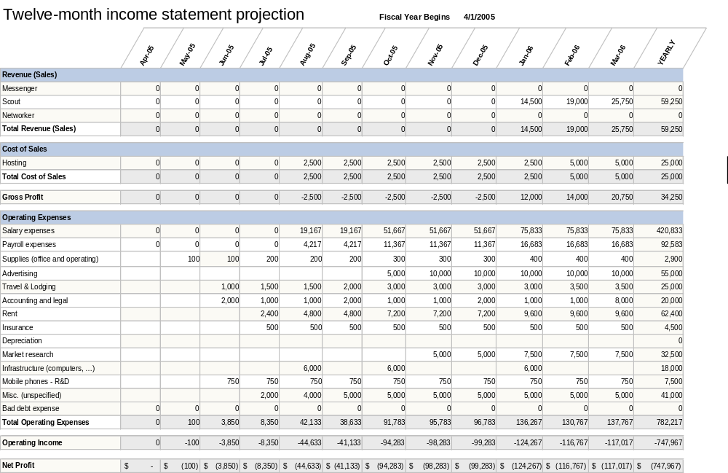
Figure 11: 12 month income statement projection (year ending March 31, 2006)

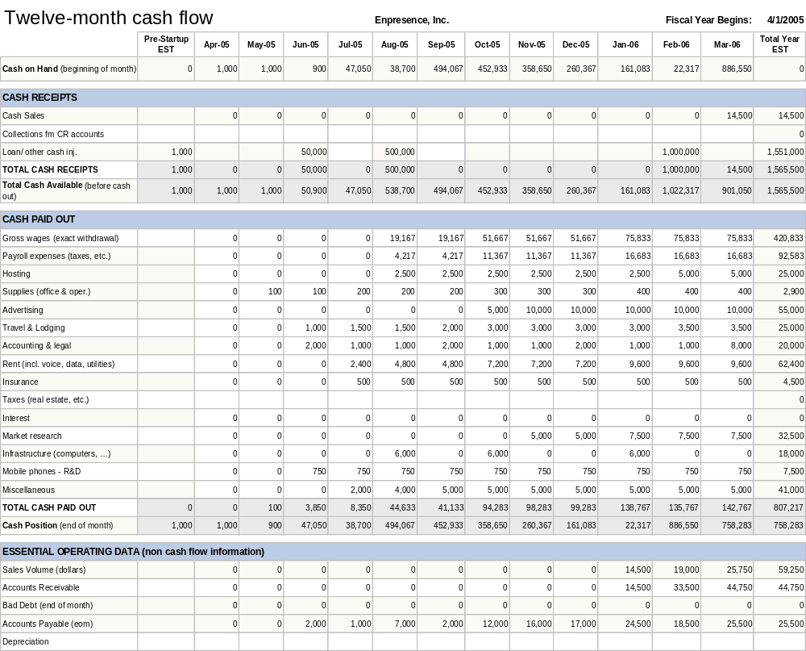
Figure 12: 12 month cash flow projection (year ending March 31, 2006)

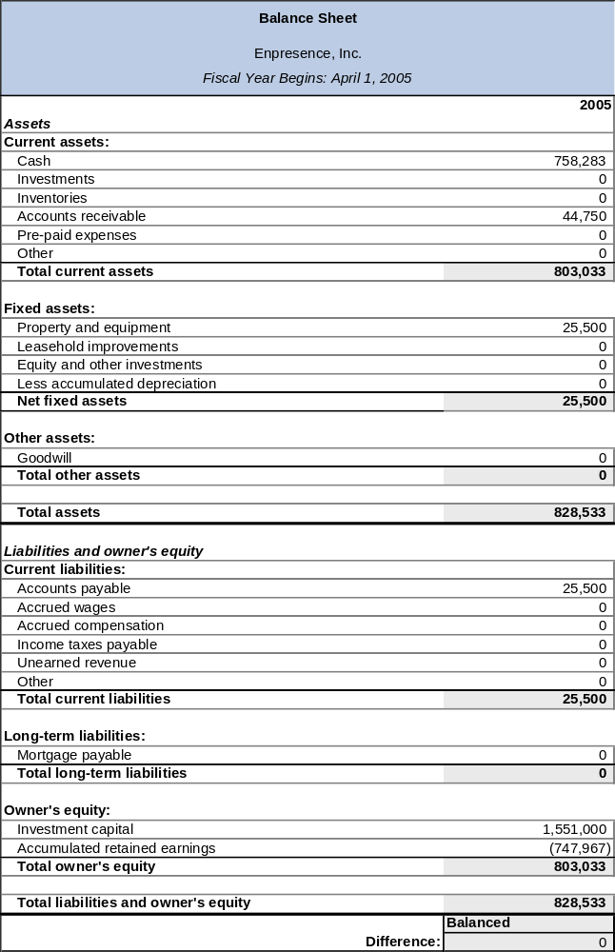
Figure 13: Pro Forma Balance Sheet - Year 1 (year ending March 31, 2006)

Key assumptions
- Payroll expenses are expected to be 22% of base salary. This includes all payroll taxes, insurance and other employment related expenses. This is based on prior experience in the technology sector.
- Central servers and member website hosting will cost $2,500 per month per 20,000 members.
- Rent and communication services for Enpresence staff
Sales & Marketing

The Enpresence service is highly dependent on a network effect, much like the fax machine or the internet. The more people on the service, the greater the value. To that effect, our sales and marketing strategy is geared around rapidly developing a customer base. To maximize the growth of our network and install base of our technology we are taking a two pronged approach designed to reach a broad customer base by selling through a network of partners, as well as to develop a direct customer base.

Partner Strategy
By targeting companies with an established customer base in the online dating (or social networking) markets, we will be able to reach a large audience rapidly. Our value proposition to the large dating services (e.g. Match.com, eHarmony, Yahoo! Personals) is to enable them to enhance their offering to customers through a co-branded solution with Enpresense. This would extend the reach of the company’s dating network beyond the internet and into the real world. With the larger services, Enpresence would get a smaller portion of the customer fee, but could gain access to a broad customer base more quickly.

In addition to the large dating sites, there are a large number of smaller dating sites, more specialized (e.g. JDate which caters to Jewish singles and BlackPlanet which caters to African-American singles). A partnership with Enpresence would further differentiate these services from their competition. With the smaller sites, Enpresence would provide increase value to the partner, thus allowing us to capture a greater portion of the customer fee, than with the larger players.

Direct Strategy
In addition to selling through partners, we intend to sell directly to consumers less aggressively than through partners. This will help balance the risk in selling through partners, as well as give us a more direct connection to our consumer base (key in developing and enhancing our product base). We intend to accomplish this by utilizing advertising on the internet, as well as through guerilla marketing techniques to generate word of mouth. These techniques include hosting events at college campuses and sponsoring happenings at local venues (bars, clubs, retail outlets). Our strategy is to focus on geographies with the appropriate level of density and social interest, such as large colleges and cities.

Pricing Strategies
Our pricing strategy reflects the two prong marketing strategy. We intend to offer a bulk rate for sales through partners. We anticipate a selling price of $750 to 1000 per month per one thousand users. While this is subject to negotiation, we believe that partners will be able to offer the service to their customers at 3-4 times that rate.
For direct customers, we anticipate a price point of $5-10 per month (match.com charges $25 per month while eHarmony charges $50 per month). We intend to conduct consumer research over the next year to nail down an appropriate price point that is appropriate to the consumers perceived value of the service and relates to the specific features provided by the service.
In both cases, we anticipate offering a 3 to 6 month free trial period to customers. This will drop the barriers to trying the service and give us an important growth in our relationship network. The rate of conversion from trial to subscriptions should be high, provided trial customers get a critical mass of friends on the service.
The Team

Ben Taylor
Co-founder and President
BIO

Ben is a career entrepreneur and consultant who has successfully built high-tech services companies that have notable differentiators. Prior to founding Enpresence he co-founded E5 Systems, a first-of-its-kind American offshore services firm that offers application maintenance, development and consulting services sourced in China. E5 Systems is a venture backed company founded in 2001 with a $10 million investment by Bain Capital.
As Vice President of Operations and CIO Ben built a revolutionary services model for software maintenance that took advantage of low cost labor to support low-value high-cost maintenance outsourcing. Ben also developed E5’s delivery methodology and lead a team to get the company certified at CMM level 3 in less than one year. In his role as CIO Ben oversaw the implementation of a global IT infrastructure that integrated solution centers in China and India with corporate resources in the United States at client sites. His broad range of skills, can do attitude, and exceptional leadership skills enabled him to take on many diverse roles and to make E5 a model for the offshore outsourcing industry.

Prior to founding E5 Systems, Ben co-founded NerveWire, Inc., where he brought his far-reaching skills in crafting implementation solutions for the Internet and Electronic Commerce. In his role as Vice President of Innovation and Services at NerveWire, Ben was responsible for building the NerveWire services and methodology; for the company’s geographical expansion to New York and San Francisco; and for creating and overseeing the employee training and boot camp. NerveWire was funded with $60 Million by Thomas Cressy Equity Partners in 1999 and was sold to Wipro in 2003. During Ben’s tenure at NerveWire the company was successfully grown to profitability and hired 300 employees in under two years.

Before founding NerveWire, Ben quickly rose through Cambridge Technology Partners, culminating in the position of Chief Internet Architect. He has delivered more than 100 projects, including several award winning, e-commerce business solutions. He has crafted implementation solutions to take clients from concept development to tangible success. Building a solution strategy required Ben to understand each client’s business needs and priorities and to help them assemble a plan regarding with whom they should partner, what technologies should be used, whom they should hire, and how they should go to market.

Ben was the creator of and developed Cambridge’s CoRad (Consumer Oriented Rapid Application Deployment) methodology for the delivery of e-business solutions including the disciplines of creative, cognitive, business and technology. Ben has extensive hands-on experience in delivering projects across several diverse industries, including telecommunications, finance, automotive, manufacturing, and government, and retail. In developing CoRad Ben lead a senior team in the definition of services, deliverables, staffing, and delivery approach to delivering industry leading Internet solutions. Upon completion he lead the management team in the refinement of the business model, budget, and strategy.

During his tenure at Cambridge Technology Partners, Ben served as an architect, project manager and practice manager. As a practice manager, he was also responsible for worldwide delivery of Cambridge’s hallmark Rapid Solutions Workshop (RSW) service offering; he managed a large team of local and regional delivery experts to insure the successful delivery of RSW services globally.
Ben holds a B.A. in Art and Semiotics from Brown University.

David Cowing
Co-Founder and Vice President

David Cowing has 15 years of experience in technology, consulting, and management. He has worked on the management teams of startup companies, as well as led the development of teams and groups within dynamic consulting companies. Throughout his career he has brought a diverse set of skills (technology expertise, management capability, and customer/presentation skills) to bear on the task at hand.

Most recently, David has been involved in assisting a leading investment bank in the development of a user oriented FX trading platform. Prior to that, David was the Chief Technologist for Niteo Partners, a systems integration division of NEC, where he consulted with projects and clients on technology issues, investigated potential uses of new/emerging technology, and worked closely with Niteo’s technology partners to address client technology challenges. Prior to Niteo Partners, as the Director of Technology for ZEFER New York, David Cowing was responsible for developing the technology direction and organization, as well as providing thought leadership on technology projects.

Prior to Niteo/ZEFER, David was with Cambridge Technology Partners, where he most was one of the founders of their Interactive Solutions practice and the east coast regional technical manager for Interactive Solutions, a group of 120 people that generated over $18 million in revenue in its first year. Prior to CTP, David was the manager of application development at AdValue Media Technologies, where he was one of five founders and was responsible for a team developing a cross platform interface to a networked solution for buying and selling television spot advertising.

David has a BA from Cornell University in Computer Science and an MBA from New York University Stern School of Business. David is a member of Beta Gamma Sigma, the national honor society for business schools.

Risks

Given the very early stage in the development of the mobile relationship networking market, there are clearly risks that may play out as the market develops. We highlight a couple that we’re watching closely, and what we’re doing to address the risk:

Trends regarding security of mobile applications. The Enpresence mobile platform utilizes user authentication, as well as an application to application authentication technique. No core user data is transmitted between phones without the user initiating the exchange. The platform also utilizes appropriate encryption and authentication when communicating with central servers.

Trends about user privacy. Privacy issues are clearly an area that will be closely watched by privacy advocate groups. The Enpresence policy is not to share specific consumer data with any 3rd parties; we regard user information as confidential. We provide features enabling users to have complete control of their information, through the use of key features: privacy mode (user is hidden from others), blocking (to prevent unwanted 3rd parties from seeing a user), and full user control of the post-match dialog.

Competition. In this emerging market, the biggest risk may come from new to market companies attempting to enter, either from parallel mobile industries (e.g. SMS providers) or entirely unexpected sources. Our strategy here is both through developing a strong base of users. Due to the proprietary nature of the network, switching costs for the user rise once they, their friends, and their social agenda begin utilizing the service.

Technology Innovation. As has been well-documented in the field of technology, innovation can be destructive. To ensure our service can survive the emergence of new technologies, we have specifically designed the platform to isolate areas of technology that we deem to particularly susceptible to this (such as proximity detection). In addition, we will closely watch the progression of key technologies that could be useful or destructive to use (such as potential alternatives Bluetooth like Ultra Wide Band and ZigBee).

Beyond these risks, there are several key assumptions that we will aggressively seek to verify in the upcoming year. These assumptions are based upon analogous markets, but may or may not apply in this market:

Price point. Early on we will offer a trial period to acclimate users to the service. We will utilize such marketing techniques as surveys of early customers and conjoint analysis to determine the value placed on features and to support/revise pricing strategy.

Adoption rate. As stated earlier, our business has a network effect component to it – the more users utilizing the service, the greater the value to them. We will closely monitor the adoption rate of users and attempt to determine how efficient our marketing strategy is at driving adoption. We plan to develop data on drivers of awareness, trial, adoption, retention, and cancellation as we role out the service. We’re seeking to understand what marketing techniques, services, and product features have the greatest impact on these key metrics.

Glossary

Definition of Terms
Term | Definition
Bluetooth | An open standard for short-range transmission of digital voice and data among mobile and stationary devices (laptops, PDAs, phones, computer).
GPRS | General Packet Radio Service is a radio technology for GSM networks that adds packet-switching protocols for data transport (TCP/IP) to mobile devices
GPS | Global Positioning System is a satellite based service used for pinpointing a location. Mobile phones equipped with GPS are able to tell their location anywhere in the world using GPS.
Intelligent Matching | Intelligent matching is the algorithmic mechanism by which Enpresence matches a users search preferences with the characteristics of another person.
Location-Based Service | A location-based service (or LBS) in a cellular telephone network is a service provided to the subscriber based on her current geographic location. This position can be known by user entry or a GPS receiver that she carries with her, but most often the term implies the use of a function built into the cell network that uses triangulation between the known geographic coordinates of the base stations through which the communication takes place.
PDA | Personal Digital Assistant. A handheld computer that serves as an organizer for personal information and increasingly incorporates mobile phone technology.
Presence Sharing | The electronic state of being present. Instant Messenger programs such as Yahoo! Instant Messenger share a user’s presence by notifying members of their “Buddy List” of their online status. If a buddy is online it means they are available to engage in an Instant Messenger conversation.
Proximity-Based Service | A proximity-based service (like a location-based service) is used to position a subscriber’s relative proximity to another subscriber or service that may or may not be at a fixed coordinate. Proximity-based services differ from location-based service in their non-geographic nature. See Location-Based Service.
Relationship Networking | Person to person networking using technology to maintain contact information and to conduct social exchanges such as messaging. Example: Instant Messaging applications maintain a “Buddy List” of personal relationships.
SMS | Short Message Service – a feature on mobile phones that allows a user to send and receive short text messages.
Social Network | Social networks are online communities of people who participate in social interaction (typically messaging) using the Internet. Example: Friendster, match.com, etc.

Appendix

Research
Following are references to materials used to support this document.

Noah Elkin, “Wireless Content,” eMarketer, July 2004, 1.
Noah Elkin, “Wireless Content,” eMarketer, July 2004, 2.
“US Wireless Voice and Data Market, 2000-2007,” eMarketer, 2004
US Census 2000 & 2004 population estimate, http://www.census.gov

